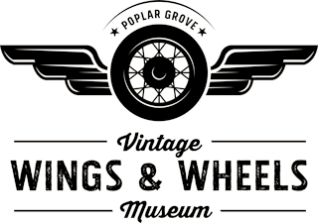

Twenty years ago this June 6th, the Vintage Wings and Wheels Museum initially opened its doors. During those 20 years, the Museum was a community center and a museum, staffed by dedicated employees and volunteers. Then the pandemic came. The Museum was closed. When we finally reopened, we had lost members and volunteers. And after 20 years, the Museum was no longer new.

Between now and May 4th, our opening date, we are going to reorganize and renew the Museum. It is a big job. We will need help. If you were a member, please renew your membership. If you haven’t been a member, now is the perfect time to join. Then come and volunteer, be a part of our renewal, do a little work, have some fun and meet old and new friends.

We sent an information sheet and a membership application by US Mail and email. We wanted to make sure we reached everyone. If you received only one of the letters, please contact the Museum so we may update our files.

Please read about the membership levels and the benefits for each level. Then, if desired, you may select your level of benefits, fill out the application and mail the application back to us. If for some reason you did not get an application, you may download both the information sheet and application on our website www.wingsandwheelsmuseum.org Please print the application and mail it to us. If you are unable to print an application, please call us at 815-547-3115 or email Diane Goellner at dgoellner@wingsandwheelsmuseum.org

Thank you very much,

Board of Directors, Poplar Grove Aviation Education Association

